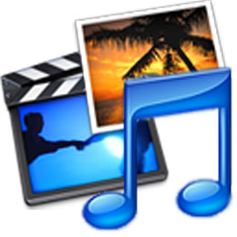

A Graphic can be a vector or bitmap images such as photographs, sprites, tiling textures, background images etc.

Vector
This type of graphic is built up by using shapes. Each shape (object) which makes up a graphic has its own set of properties also know as attributes. A full definition of the attributes of the shape is stored. This is more memory efficient than bit-mapped graphics which store the state of every pixel. Vector graphics have small files sizes in comparison to bit-mapped graphics.

Bit-Mapped
This type of graphic is made up of a rectangular grid of pixels – each of which is stored individually. The colour value of every pixel is stored. File sizes can be large since each pixel would typically take up 3 or 4 bytes. Bit-mapped graphics are captured by scanners and digital cameras. File types include ‘jpeg’, ‘bmp’ and ‘gif’.

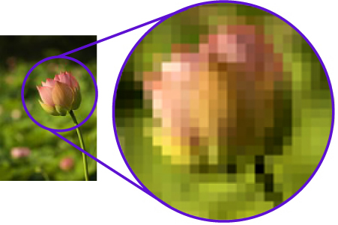
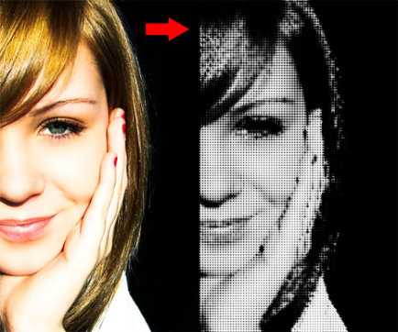
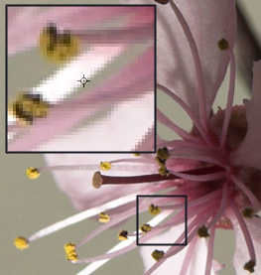

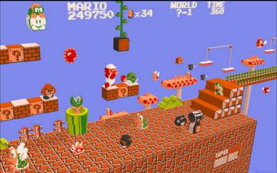
Types of graphical media assets in games:

Sprite/Avatar : characters in some games are also known as avatars. Sprites usually have a transparent outline and can be animated to simulate movement.

Background : this image is a type of texture that shows a landscape image.

3D Objects : items or characters that can be placed within the game.

3D Levels : laying out the areas of game play, such as hills, cities, rooms, tunnels for players and characters to move around in.

Skyboxes : is a cube with background images that surrounds the game player in a 3D game.

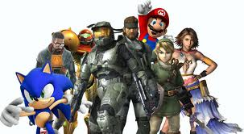
Textures : attributes of graphics. This attribute defines the surface appearance of what objects look like. It can be thought of as the skin that wraps around the 3D framework of the object to give it more realistic appearance, images that are mapped onto surfaces of objects such as stone walls and wooden tables.

Comparison of graphics

What are the differences between vector and bitmap graphics?  - Resolution independent – resolution dependent  - Small file size – large file size  - Unrealistic images – realistic images  - Edit whole objects – edit to pixel level  - Order/layering of objects – flat bed of pixels | What are the different creation/capture methods?  - Hardware: digital camera, scanner  - Software: applications
What factors affect quality of graphic and file size?  - Low v high resolution on quality and file size  - Different colour depths on quality and file size  - Lossy and lossless compression techniques | Graphic file types?  - Jpeg v gif
Common attributes of 2D with 3D?

- 2D : shape, position, size, rotation, line colour and thickness, fill and layer number.
The two key dimensions in 2D graphics are length and breadth.
- 3D : shape, position co-ordinates and size, rotation and texture.
2D graphics relate to an x (length) and y (breath) axis but 3D graphics have a 3rd axis, the z-axis which relates to the depth of the object i.e. the third dimension.
3D packages allow the user to view the scene from any perspective.

A video is a moving image file in a format that is compatible with the game development environment.

File types are ‘avi’, ‘mpeg’ and ‘wav’.

Method of capture is through a digital video camera.

Tools for editing are titling and cropping.

Types of video media assets in games:
Example: including a film of background scenery changing over time.

Comparison of videos
Things to consider when comparing videos include:

- Effect of changing frame rate
- Colour depth
- Resolution
- Duration on file size and quality

This is a collection of still images with each one in the sequence slightly different from the previous. The images are played quickly one after the other to give the illusion of movement.

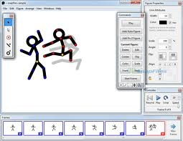
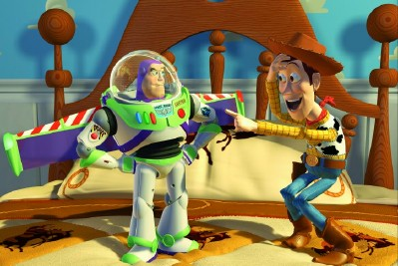

Types of animation media assets in games:
Example: a moving cartoon character.

Comparison of animations
Things to consider when comparing animations are:

- Different methods of creating animation
- 2D with 3D animation

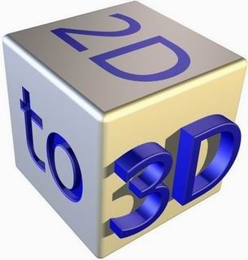

This is any type of sound in a game. Types of audio include:

Speech
Such as the voices of characters.

Sound Effects
Such as noises of objects in the game.

Music
Background music that usually loops and repeats during the game play.

File types are ‘raw’, ‘wav’, ‘mp3’ ‘midi’. Methods of capture are from a microphone, extract from a CD, using an audio keyboard. Tools for editing are echo, change pitch, speed, amplify and change tempo.

Comparison of audio speech

Voices?  - Human or aliens  - Monster or animal  - Outside or inside  - Talking loudly or whispering | How do characters demonstrate emotions?  - Happy v sad  - Angry v happy
Does stereotyping in voices exist in this game?

- Male v female
- Hero v villain
- Young v old
- Alien v human

Comparison of audio sound effects

What are the sound effects?  - Noises of objects in the game | 3D sound v surround sound  Straight v Foley sound effects
How are these sound effects stored on the computer?  - File types | Compare:  - Realistic v non-realistic (such as synthetic sound)  - Mono, stereo, multi-channel and surround sound  - Different types of data compression and the relative merits/demerits
Compare industry standard software tools:
- Sound Forge, Wavelab Peak, CoolEdit, Protools, Nuendo
Comparison of audio music

What music is in the game?  - Background music that loops and repeats during game play | How is music used in the game?  - Create atmosphere  - Give feedback  - Opening music v win/loss and credits
What are the different file types?  - ‘midi’, ‘aff’, ‘wav’ | Linear music stream v interactive music  Music at selection v game play
Is is:  - Mono, stereo, multi-channel, surround sound? | Different types of data compression and their relative merits/demerits.
Industry standard software such as:

- Logic, Cubase, Protools, Nuendo, Gigastudio

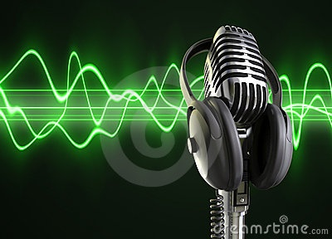
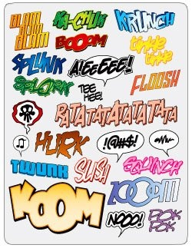

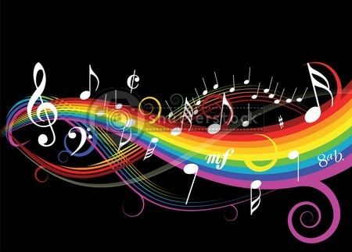

These are required for the game to provide dialogue, create an atmosphere and give the player feedback or instructions.

File types include ‘txt’ and ‘rtf’. Methods of capture include the keyboard, scanner, voice recognition and handwriting recognition.

Types of animation media assets in games:

Text Files: needed to give dialogue or instructions. Need to think about the font, size, colour.

Scripts files: identify what scripts need to be written an what can be sourced form library in order to make game work. Need to this about the code for using within game development environment.

Comparison of audio music

How are text media used in the game?  - To provide dialogue  - Create an atmosphere  - Give player feedback  - Instructions | Think about the different styles of writing and how they impact on different audiences.
Identify tools for checking grammar, punctuation and spelling. | Consider file types : ‘txt’ and ‘rft’.

