Music Festivals UK is a company that provides music lovers with a list of different music festivals that are taking place in the UK. To try to obtain a greater share of the ticket sales, Music Festivals UK would like to have a website developed that will give details of UK festivals.

You have been asked to create sample web pages that will give Music Festivals UK some idea of what the final website would look like. As it is only a sample, you do not need to create the entire website, just the Home page and four other web pages.

When users visit the website Music Festival UK would like a list of the current music festivals the customer can pick from. When a festival is selected a new web page should open giving the user information on dates, locations, bands that will be performing as well as some pictures.

They would also like a page created for their stock ‘festival essentials’. This includes the likes of fold away stools, raincoats, wellies and tents.

The design of the five web pages you have to create is shown below:

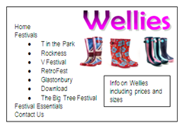
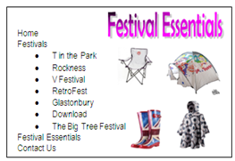
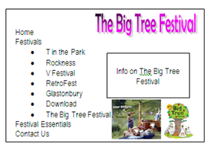
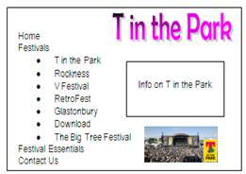
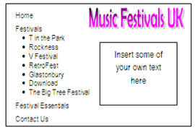

What you have to do
Your assessor will give you access to a web authoring application required tocreate the web pages. You have to create the sample website pages shown on the previous page.

Task 1
Create the web pages ensuring that:

- The Home page is the opening page.

- On all pages, clicking on ‘Home’ in the navigation bar will take the user to the Home page.

- On all pages, clicking on the 2 festival names you have selected in the navigation bar will take the user to corresponding festival page.

- On all pages, clicking on ‘Festival Essentials’ in the navigation bar will take the user to the Festival Essentials page

- When any of the images on the Festival Essentials main page is clicked, it will take the user to the details about that item.

You should make sure that you format all the objects in the web pages so they match the ones shown above as closely as possible.

Task 2
Describe any problems or errors that you encountered during the creation of your web pages and how you solved them.

Task 3
Describe one of the features and one of the functions of your web pages.

Task 4
Name and describe the software you used to create your webpages.

Task 5
Once the website has been completed, Music Festivals UK want to publish it. They will need a web server to deliver the content
- Search the internet for a web server that is less than £1,500
- Write down the name and cost of the web server you have found.
- For your chosen web server write down:
i)The processor clock speed
ii)The storage capacity
iii)The available RAM
- Suggest one security risk to Music Festivals UK website and what they could buy to take precautions against this risk.

