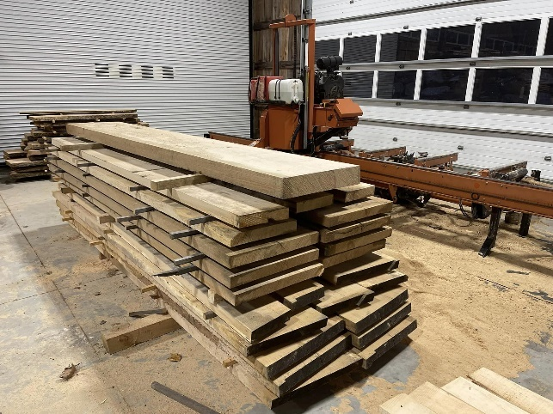
A sawmill cuts 3 metre planks of wood into regular lengths.
The lengths vary according to what customers request.
A program is written to store and process customer orders.
The orders are stored in a txt file with customerID, wood type, lengths, number of planks being stored as shown in the example file lines below:
192836,Oak,1.5,60
283746,Beech,1.25,110
The order data is read from the file and stored in an array of records.
(a) The top-level algorithm is shown below. Complete the data flow for this algorithm. 5
Step 1 | Write new customer order to file | IN:
 |  | OUT:
Step 2 | Read customer orders from file | IN:
 |  | OUT: orders(customerID, type, length, planks)
Step 3 | Display orders for a selected customer | IN:
 |  | OUT:
Step 4 | Find and return the number of orders of a selected wood | IN: wood, orders(customerID, type, length, planks)
 |  | OUT:
Step 5 | Display the number of orders for the selected wood | IN: numberOfOrders
 |  | OUT:
Step 6 | Calculate and display the waste wood for a selected wood type | IN:
 |  | OUT:

(b) Using a programming language of your choice, define a suitable record data structure called “CustOrder” to store the data for a single customer order. 2

(c) Using a programming language of your choice, declare a variable, called “orders”, that can store the data for 50 000 customer orders. Your answer should include the record data structure defined in part (b). 2

(d) The code for step 4 is implemented as shown below:
FUNCTION countOrders(ARRAY OF CustOrder orders, STRING wood) RETURNS INTEGER
DECLARE count INITIALLY 0
FOR counter FROM 0 TO length(orders)-1 DO
IF orders[counter].type = wood THEN
SET count TO count + 1
END IF
END FOR
RETURN numberOfOrders
END FUNCTION
Using a programming language of your choice write code, for the main program, that: 3
- asks the user to enter the type of wood they wish to count
- calls the above function and assigns the value returned

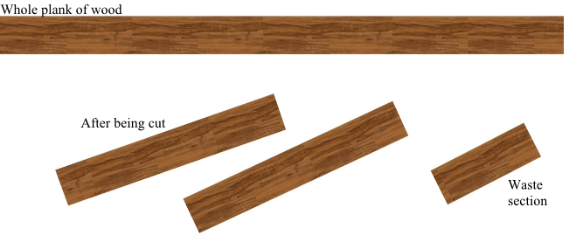
(e) If a customer orders 100 lengths of oak that are 1.2m each in length, they will require 50 of the 3m planks to be sawn to complete this order. This will produce:
- 50 x 2 planks, each 1.2m in length
- 0.6m of waste wood from each of the planks
A pseudocode design for step 6 is shown below.
Set total to 0
Open file
For each customer order in the file
If the order is the selected wood type
calculate waste wood (in metres) and add to total
End if
End for
Close file
Display total amount of waste wood in metres
Using a design method of your choice further refine “calculate waste wood (in metres) and add to total”. 4

