Computing Science – National 5
Course Summary

Software Design and Development
Computational constructs | Expressions to assign values to variables
Expressions to return values using arithmetic operations
+ - * / ^

Execution of lines of code in sequence demonstrating input – process- output

The Algorithm below
- 2 inputs
- 1 process
- 1 output

1. Send “Enter First Number” to display
2. Receive first_number form keyboard
3. Send “Enter Second Number” to display
Input
4. Receive second_number from keyboard
Process
5. Set total to first_number + second_number
Output
6. send total to display

Expressions to concatenate strings and arrays using the & operator

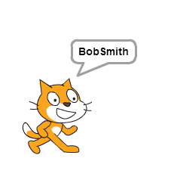
Bob Smith is an example of concatenation
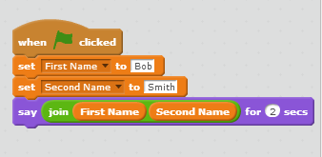

Use of selection constructs including simple and complex conditional statements and logical operators.

This is a simple statement as there is one conditions
1. If pupil_mark >=50 then
2. send pass message to display
3. Else
4. send fail message to display
5. End if

This is a complex statement as there are two conditions
1. If pupil_mark >=50
2. And assessments_mark = 100 then
3. send pass message to display
4. Else
5. send fail message to display
6. End if
Iteration and repetition using fixed and conditional loops
Fixed loop below as it will loop a fixed number of times depending on the users answer
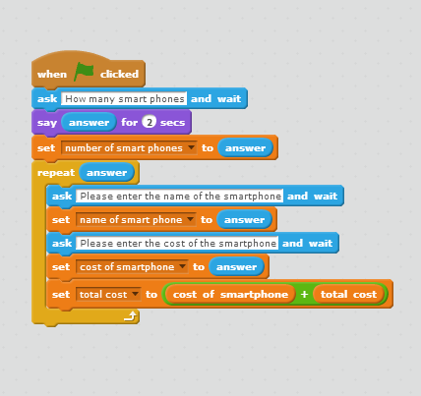

Below is a Conditional Loop as it depends whether the user has any money left.

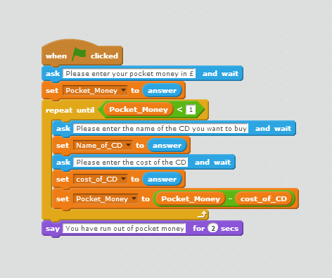

 | Pre-defined functions (with parameters) - RND will round numbers 22.34 becomes 22 or Root 4 will become 2, or 9 will become 3.
Data types and structures | String - text variable like name
integer - a round number used for number of people or items
real - contains decimals used for distances or measurements
 | Graphical objects - pictures
 | Boolean variables - Yes or No
 | 1D arrays - used for a variable with many pieces of data all of the same data type. Pupilname (20)
Testing and documenting solutions | For an exam out of 100  Normal – 78, 45,67, 85, 44  Extreme – 0, 100  Exceptional - -89, bob
Errors
Syntax – The rules of the programming language have been broken. E.g. a typing mistake Displya rather than Display
Execution – using Average = total / 0 would give an execution error.
Logic –will only show up when you run the program. Please see below
Counter = 0
Repeat
Counter = counter + 1
Until counter = 0
Readability of code
internal commentary - information about what the program does written by the programmer alongside the actual code. Green in Livecode.
meaningful identifiers - Calling variable names that mean something length or height rather than L or H
indentation starting parts of the code slightly into the middle of the page making it easier to read.
Algorithm Specification | Input validation - checking that what is entered by the user is acceptable e.g. that an age isn’t a negative number.  1. Repeat  2. Send “Please enter data” to display  3. Receive data from keyboard  4. If data is outwith range then  5. Send “re-enter data” to display  6. Until data is within range
Design notations  also applies in ISDD | Pseudocode example 1  SET total TO 0  SET count TO 0  WHILE count ˂ 10 DO  RECEIVE nextInput FROM KEYBOARD  SET total TO total + nextInput  SET count TO count + 1  END WHILE  SEND total / 10 TO DISPLAY  Pseudocode example 2  RECEIVE age FROM KEYBOARD  WHILE age ˂ 0 OR age ˃ 130 DO  SEND “Enter an age between 0 and 130” TO DISPLAY  RECEIVE age FROM KEYBOARD  END WHILE
Structure Diagram
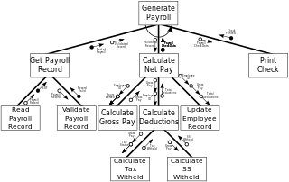

Flow Chart
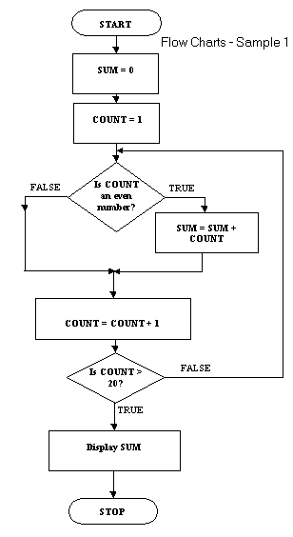

Low-level operations and computer architecture | Units of storage:  8 bits = 1 byte  1024 bytes = 1 Kilobyte  1024 Kilobytes = 1 Megabyte  1024 Megabytes = 1 Gigabyte  1024 Gigabytes - 1 Terabyte  1024 Terabytes = 1 Petabyte
Translation of high-level program code to binary (machine code):
interpreters - translates it line by line, spots errors more easily but takes longer.
compilers - creates the machine code in one step, less likely to spot errors but more efficient. Creates a run time version that can't be edited.
Use of binary to represent and store:
Real numbers uses mantissa & exponent - 2.56 X 10⁵
Mantissa = 2.56 Exponent = 5
Characters - ASCII allocates a different binary code to each letter, A = 00100001
I instructions, machine code - the only characters the processor can understand 10101011101
Graphics bit-mapped and vector
Bit-mapped, graphics are made up of pixels
Basic computer architecture:
Processor
- Registers - temporary storage locations holding data being processed
- ALU – deals with comparisons and arithmetic calculations
- control unit - controls all other parts of the processor, ensures instructions are carried out in the correct order
Memory
- Random Access Memory - temporary data storage only held as long as the computer is switched on.
- Read only memory - Permanent memory not lost when the computer is switched off. Data stored on a hard disk or a memory stick.
Buses
- data - carries data to and from the processor, memory and other devices. Bi-directional
- address - carries address info from processor to the memory.
- control - made up of a number of separate wires.
In interfaces
allows a processor to send and receive data to and from peripherals like printers, scanners, keyboards and projectors.
Binary Decimal Conversion | 128 64 32 16 8 4 2 1  1 1 1 1 1 1 1 1 = 255  0 1 1 0 1 0 0 1 = 105
Computational Constructs | 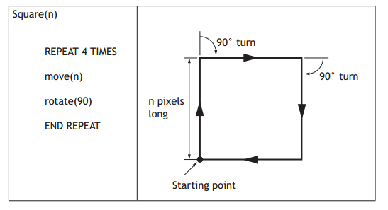  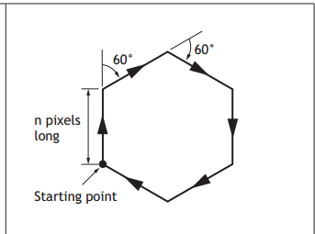  Hexagon(n)  Repeat 6 Times  Move (n)  Rotate (60)  End Repeat
Calculations | Formula  Number of pixels = image width x resolution x image height x resolution  Example 1  This is enlarged but is 1 inch by 1 inch.  In that case there are 72 x 1 x 72 x 1 = 5184 pixels  Example 2  Bitmap with a resolution of 600x600 pixels in 8 bit colour.  Storage requirements  600 x 600 x 1 bytes = 360000  It is 1 byte as it is 8 bits per pixel  360000/1024 = 351.6 kilobytes  Example 3  Calculate the number of pixels in 4 inch by 5 inch photograph scanned which has a resolution of 600 dots per inch.  Pixels = 4 x 600 x 5 x 600 = 7,200,000 bits  7,200,000 / 8 = 90000 bytes  90000 bytes / 1024 = 878.9 Kb  Vector Graphics  It is possible to edit each object separately, for example, change the shape, colour, size and position.  Even if an object in a vector graphic is quite large, it doesn't need a lot of computer memory. Therefore the file size of a vector graphic is often very small.  Vector graphics are scalable when you resize them, they do not lose quality.

Information Systems Design and Development
The following concepts and vocabulary may apply to a range of information systems types and contexts including:
Databases, websites, games, mobile applications, kiosk systems.
Structures and links  database | Database structure:  field - the fields below; Exhibitor, Company Name, Area, Stand Number, Product Reference, Item Name, Price (£)  record - A single row in a table, there are 8 records below  file - the entire database
Database structure:
flat file all the data is stored in one table 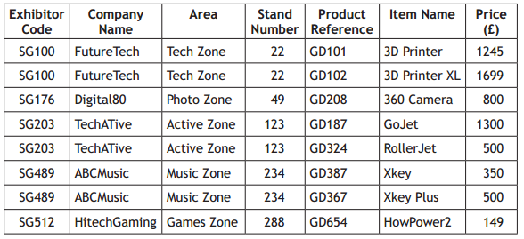
Drawbacks Data duplication Data inconsistency or update/ deletion/insertion anomalies Data integrity errors (due to data inconsistency) Inconsistent search results in multi-value fields
linked tables
Table would be split into
EXHIBITOR(Exhibitor Code, Company Name, Area)
PRODUCT(Product Ref, Item name, Price (£), Exhibitor Code*)
primary keys - these are unique identifiers for each row in a table
foreign keys – a primary key from a different table
Database operations
Simple search – a search on ABC Music would return the following

Complex search – Searching on two (or more) fields at once for example Company name = FutureTech and Price > 1500 would return the following

Simple sort – Sorting a table by one field, class registers are sorted by surname
Allan, Tom
Bennet, Gordon
Clark, Petula
Donaldson, Luke
Elliot, Paula

Complex sort – same as above but if two people have the same second name they are sorted by first name as well
Allan, Tom
Bennet, Gordon
Clark, Petula
Donaldson, Luke
Elliot, Paula
Ferguson, Alex
Ferguson, Sarah
This is in Alphabetical or Ascending order
Field types
text – A Roberts, ML1 3XF
numbers - 124
date – 29 April 2012
time – 08:30
object – Picture, video or sound file.
calculated – pay * 20%
link – www.bbc.co.uk
Boolean – either yes or no
Validation
presence check – data must be entered before the user can continue, usually has a star.
restricted choice - please see below, the user can only select one option.
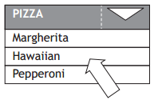
Benefits
Reduces the chance of human error
Does not require the user to type a text response
Speeds up the ordering process as inputs are reduced to mouse clicks
Allows the use of a touchscreen
Good design to avoid data duplication and modification errors (insert, delete, update)

Flat file databases can lead to errors as shown below
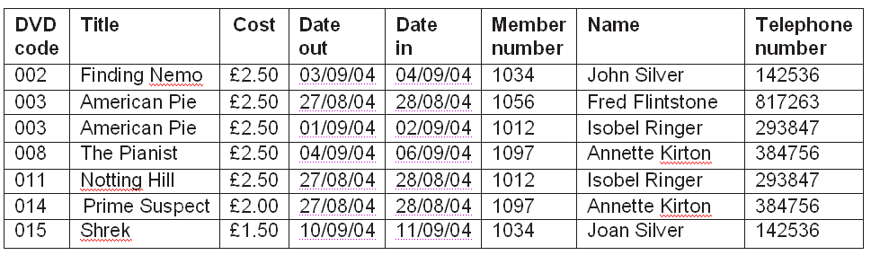
Is it a man John Silver or a woman Joan Silver?

Structures and links  web based | Website – a series of web pages linked together, bbc.co.uk has thousands of linked pages  Page – A single page written in html on the internet, normally forms a website when linked with other pages  URL - Uniform Resource Locator - http://www1.skysports.com/football/
Hyperlinks
Internal – links to pages on the same site
External – links to a completely different website.

relative addressing – code to link to weather would be <a href=”/weather” >/a
Benefit – less coding, link will still work if the domain name changes
absolute addressing - code to link to weather would be
<a href=”http://www.bbc.co.uk/weather” >/a
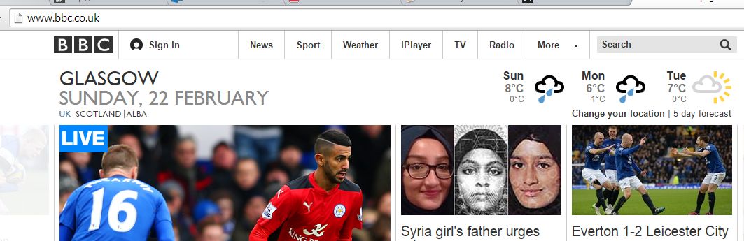
Benefit – easier to follow the code as it shows the whole address.

 | Navigation - back, forward, home.
Web browsers - software allowing web pages to be viewed. Firefox, Chrome, IE
search engines - provide a list of links when a user types a search. Google, Yahoo, Bing
Good design to aid navigation - links clearly marked, consistent style
usability - Video clips, forums
accessibility - large text available, alt tags on pictures
Testing websites | Check navigation  Checks all hyperlinks/hotspots  Ensure graphics are not pixelated  Ensure audio clips run  Check JavaScript issues  Check compatibility with browsers
User interface  also applies to SDD | User requirements  visual layout - eye-catching, simple to use and clear of cluttered buttons and text.  navigation - hierarchical, with links organised into sub categories, or linear, where pages are visited in one step-by-step order.  selection – options include clicking on a menu or radio buttons or filling in a form.  consistency – using the same font, colours styles & menus  interactivity – using video/audio, allowing users to post comments etc  readability – use white space and short pages to ensure it is easy to read.  Accessibility – Reading text aloud or having large fonts for users with eyesight issues.
Media types | Standard file formats:  - Text: txt, rtf  - Audio: wav, mp3  - Graphics: jpeg, bmp, gif, png  - Video: mp4, avi  - Pdf: Portable Document Format
Factors affecting file size and quality
resolution - the number of pixels used to make up the picture.
colour depth - the number of possible colours used to make up a pixel. The more possible colours the greater the file size.
sampling rate - in sound files the number of recordings taken per second., the greater the sample rate the higher the quality and file size.
 | Need for compression - reduces the file size so that the web page loads more quickly. Reducing bit depth has the same impact. Quality of the image is affected.
Coding | Scripting languages - JavaScript is used to make the webpages interactive, eg display date/time
 | Mark-up languages - HTML used to code the webpages, styles can be used.
Purpos, features, functionality, users | Description of purpose, main features and functionality
Users: expert - use keyboard short cuts
novice - require extra help, clear menus age-range
hardware | Input devices - put data into the processor e.g scanner, keyboard, mouse  output devices - display data from the processor e.g. monitor, printer, projector,
Processor type - dual, triple and quad code
speed (Hz) - 1.8GHz to 3.4Ghz (faster)
Random Access Memory - used for current files, temporary storage of data which is lost if the device is switched off.
Read Only Memory - ROM retains its memory even after the computer is turned off.
Device types
Supercomputer - large processing power and memory, used by large organisations.
Desktop - processing power but not portable.
laptop - portable but generally less powerful than a desk top
tablet - portable but no physical keyboard.
smartphone - use 3G or connect to wifi. same functions as a tablet.
software | Operating systems - controls and organises the general operation of the computer. Windows, iOS, Android
 | Web browsers - allows web pages to be viewed e.g Chrome, Firefox, IE
 | Utilities - software installed on the Operating System e.g defragment, anti virus, compression
storage | Local - storing data on your own device  web/cloud - storing data to a remote server on the internet.  Benefits of the web/cloud  Can access data from any computer device remotely. No requirement for own servers, less need for own technical support on site. Automatic backup/recovery of data
 | Capacity - Measured in GB & TB eg laptops have either 500GB or 1TB of storage. Servers in companies have far more.
Rewriteable - Data can be removed and added any time e.g. USB stick
read-only - as soon as data is saved onto the device it can't be edited. e.g FIFA15
 | Interface - Allows data to be converted between the processor and devices like printers and keyboards .
 | Data transfer speed - Thunderbolt is faster than usb 3.1 which in turn is faster than firewire
Storage devices
- Built-in - each device like a laptop or phone has storage space within it.
- external - external hard drives allow users to do backups
- portable - usb drives are very portable
- Magnetic - like a an old style video tape.
- optical - DVD and CD, can become scratched
Solid state - robust as there are no moving parts
networking / connectivity | Stand-alone - using a device but not connected to the internet, not common now.  networked - a number of devices linked together to share data, internet, printers, communication.
LAN - Local Area Network - A number of devices linked together in 1 location e.g. a school
WAN - Wide Area Network - A network linking different locations used by banks & supermarkets
internet - largest WAN, about 10 billion devices linked together
 | Client Server Data can be stored/accessed centrally. Only accessible by registered users. Different access rights for users . Shared peripherals . Expensive as they have to purchase servers and additional hardware.
 | Peer to Peer Resources stored on device available to other peers . No centralised stored .Not as secure as Client Server Risk from viruses
Security risks | Viruses - software written specifically to cause hard to a computer system  Worms - malware that can copy itself from device to device  Trojans - harmful software designed to look like something useful to the user e.g. a downloaded mp3 file.  Hacking - unauthorised access to a computer system.
Spyware - records actions carried out on a computer without the user knowing. Can find out websites visited and passwords.
Phishing - Sending fake emails which link to a fraud site asking people to enter secure information like account numbers and passwords.
Keylogging - Software which records every key stroke entered onto a computer. The fraudsters can then work out usersnames/passwords.
Online fraud - paying for goods that don't arrive or being conned into sending bank details.
Identity theft - criminals find out enough personal details about someone to obtain loans/credit cars/products in their name.
 | DOS Denial of Service attacks - so many requests are sent to a computer in a short space of time that it crashes.
Security precautions | Anti-virus software - Software like Avast and Norton which scan for viruses and delete them.
 | Passwords – guidelines to make a strong password, number of characters, mix of lower/uppercase, special characters.
 | Encryption – Converting a message into code so that it can’t be read by a hacker
 | Biometrics – recognises parts of the body to allow or restrict access – fingerprints, iris, (eye) facial recognition.
Security protocols - makes the website more secure when users are accessing online banking etc
Firewalls - block unwanted data from arriving in a network
 | Security suites - a package containing a number of different security tools to ensure the user is fully protected from all types of threats
Legal implications | Computer Misuse Act - illegal to hack into computer systems and create/send malware like viruses/trojans etc.
 | Data Protection Act - data subjects have the right to see data held about them, any errors corrected, personal data should not be transferred outwith the EU.
 | Copyright, Designs and Patents Act - illegal to copy software, music and movies.
 | Health and Safety regulations - eyesite can become damaged and Repetitive Strain Injury can happen. The solutions are eye tests and regular breaks.
 | Communications Act - makes it illegal to use a neighbours wifi without permission and trolling on social media deliberately upsetting other users.
Environmental impact | Energy use - Every electrical device, including computers, use energy, powersaving and standby mode limit the amount of energy used.
 | Disposal of IT equipment - Computers contain "heavy metals" which cause pollution. Options for disposal include; give it to charity, sell it, part exchange for a new PC, have it recycled. Make sure all data is wiped first.
 | Carbon footprint - amount of greenhouse gases produced, ways to reduce it are; videoconferencing rather than meetings, make electronic copies of documents rather than printing.

